………………… School
English Language
Intermediate Grade 2nd
1st period Exam
……….\20


Student's Name : class:

……\ 5 marks
1-Read the following passage and answer the questions below:
Ali wanted to try a new sport. One day, he joined a karate class in his town. At first, he was afraid because karate looked difficult. The teacher gave him a white uniform and white belt. Ali started to learn how to kick, block, and punch. With practice, he became stronger and more confident. His teacher told him that karate is not just about fighting, but also about respect and self-control. After many months, Ali worked hard and earned a yellow belt. Karate helped Ali become healthy, brave, and focused.
c- tennis | b- basketball | a- Karate | 1- What sport did Ali join?
c- Books and pens | b- Short and cap | a-uniform and belt | 2- The teacher gave him…………………
c-sad | b-afraid | a-hungry | 3-How did Ali feel at first in the karate class?
c-Yellow | b-Blue | a-Green | 4- Which belt did Ali earn ?
c-brave | b-tired | a-lazy | 5- Karate helped Ali become…….
A.Choose the correct answer.
……\ 5 marks
2-Choose the correct answer.

c-am | b-is | a-are | 1- Riyadh………..in Saudi Arabia.
c- sleeps | b- sleeping | a- sleep | 2- Are you …………..?
c-What | b-How | a-Where | 3-………….old are you?
c- making | b- makes | a- make | 4- Sara is …………. a cake.
c-opened | b-open | a-opens | 5-……….the book please.
c-are | b-is | a-am | 6- Aisha and Fadwa ………. at the mall.
c- smelling | b- smells | a- smell | 7- The pizza ………….. good.
c- am | b- are | a-is | 8- Who …………….your teacher?
c- eat | b- eats | a- eating | 9- Don't ………… junk food.
c-like | b-likes | a-liking | 10- I ……………..martial arts films.

3-Do as shown between brackets.
……\ 2 marks
a-( make a Yes or No question)
They are working now.
……………………………………………………………………………..…..?
b-( Reorder)
are\ Where \from \you\?..............................................................................

……\ 4 marks
4- write the correct word under each picture ( karate - volcano - elevator - credit card )
)

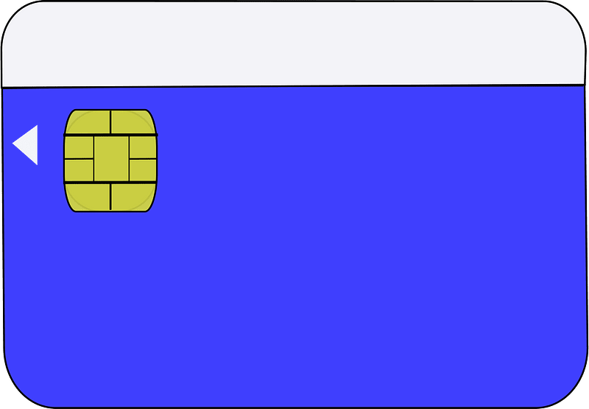
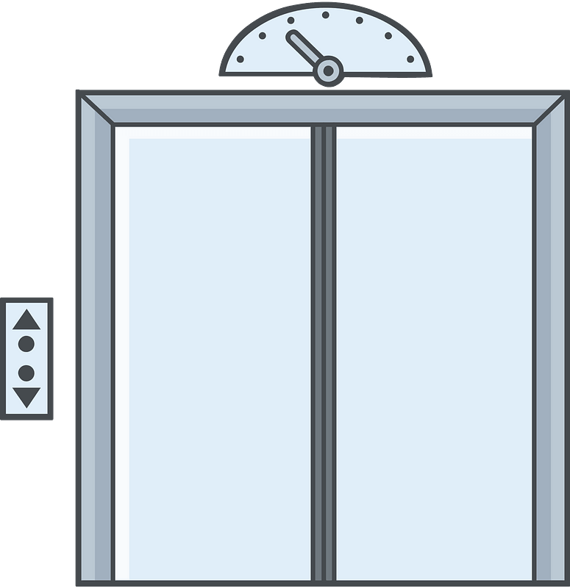
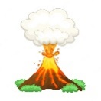
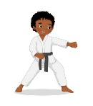

………………………
………………………
………………………
………………………

……\ 2 marks
5- Choose the correct answer.
1-(script -soup - sofa ) is the words of a movie, play, or speech
2- I'd like to make a table (business – reservation – mall ) for two people for nine o'clock.

6.Choose the missing letter.
1- I had just returned from the Cannes Film Fe….tival. ( q - s - w )
2- …ideos is becoming popular tool for e-learning. ( V- H – T)
3- The camera o…erator is holding the camera.( n – j – p )
4- During his summer ……acation, he visited Dubai. ( d - a - v )

……\ 2 marks

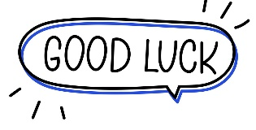

Your teacher:

............
…………..……………….. Intermediate School

Total
المجموع | تحريري | شفهي
20 | 10 | 10

First Period Exam
Second Intermediate Grade

Name ………………………………… Class ………………………………
__________________________________________________________________________________________
/ 2
Comprehension

Read the following then answer the questions:

My family and I always go to the beach in the summer. We eat sandwiches and ice cream. We will drink orange juice. My brother likes to swim. My sister likes to likes to play with dad. We all have a good time .
A- Put (√ ) for true or ( ᵡ ) for false :

( ) | 1. We go to the beach in winter .
( ) | 2. My brother likes to play football.

B- Choose the right answer:

ice cream | apple | bread | meat | 1-Thy eat sandwiches and______.
brother | friend | dad | mom | 2-my sister likes to play with _____.
_________________________________________________________________
/ 2.5
Grammar

Choose the right answer:

1- We ___________ here for the festival.
A. is B. am C. are D. do
2 - ______ are you doing? Fine, thanks
A. Where B. How C. When D. which
3 - I am ______ a book now?
A. reading B. reads C. read D. write
4 - He is _______ in a hospital now.
A. work B. working C. works D. worked
5 - The waiter _______is serving the customers is friendly.
A. which B. who C. when D. how

/ 2
Vocabulary

A- Choose the best answer to fill in the blank:
1. _________ are good places for meeting people.
D. Playground | C. Room | B. Schools | A. Hotels
.2. Good night. ___________ tomorrow
D. Good afternoon | C. See you | B. Good bye | A. Good morning
3- Are you here for the conference? No, I’m here on ________ with my family.
D. playing | C. study | B. vacation | A. hotel
4- Half of the people in Saudi Arabia are under the _____ of 25.
D. strong | C. tall | B. age | A. old
B- Put the right word under its picture:
/ 2.5
 | 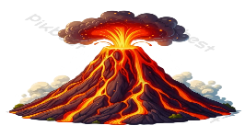 |  |  | 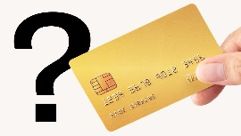

Credit card - engineer - cameraman - reception desk - volcano

_______________________________________________________________________________
/ 1
Orthography

Choose the correct letter:
k | h | d | 1. I’d like to intro_uce you to Joe.
b | m | t | 2. The soup s_ells good .

Good luck T.

Name: ……………………………
Class: 2nd Intermediate Grade
10 /
…….. Intermediate School First Exam - 1448 First Term
- Grammar:
- Choose:
- I (am – is – are) a smart student.
- This is the boy (who – which – when) had an accident
- Messi (play – plays – is playing) football now.
- The actors are ready to perform (over – in front of – under) the camera.

- Do as shown between brackets:
- Rasha bakes a cake. (Change into negative)
…………………………………………………………
- I (seeing) a bird in the tree. (Correct the verb)
…………………………………………………………

- Vocabulary:
- Write the words under the pictures:
salary – cameraman – key card – hotel – run away


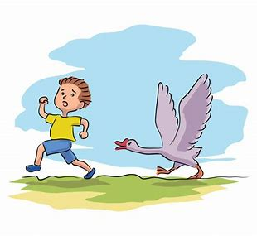


_____________ _______________ ________________ ______________

- Fill in the blank with the correct words in the box:
feed – festival – engineer

1- Fahad wants to be an ……………… in the future.
2- The baby is too young to …………………. itself.

- Match:
- All by myself a- an expression used when you give something to someone
- Here you are b-see you later
. c- with no one else’s help

- Orthography:
- Fill in the missing letters:
- I will call the hotel and make a reser__ation.
- She like to wear e__otic clothes.
- Have you ever watched this fi__m?
- The scr__pt is well-written.

Good Luck
Ms. Tahani Al-Ghamdi

