
………………… School
English Language
Intermediate Grade 3rd
1st period Exam
……….\20

Student's Name : class:

……\ 5 marks
1-Read the following passage and answer the questions below:
Sami is a teenager who spends almost all his time on the internet. He wakes up and checks his phone before eating breakfast. At school, he thinks about games and social media instead of his lessons. At night, he stays up late watching videos, so he feels tired the next day. Because of this, Sami does not play sports, and he rarely meets his friends outside. His lifestyle is unhealthy, and he knows he should spend less time online to live better.
c-play football | b- Eat breakfast | a- Check his phone | 1- What does Sami do first in the morning?
c-food | b-sports | a-social media | 2- What does Sami think about at school?
c-watching videos | b-studying | a-reading books | 3-Sami stays up late ……...
c-usually | b- rarely | a-always | 4-He …… meets his friends outside.
c- Unhealthy | b- Healthy | a- Exciting | 5- Sami’s lifestyle is………………
A.Choose the correct answer.

2-Choose the correct answer.
……\ 5 marks

c-Doing | b-Does | a-Do | 1-…….. Saad usually watch T.V in the morning?
c-works | b-working | a- work | 2- Where did they ………… ?
c-ago | b- last | a-yesterday | 3-……….. year I was in Canada
c-ate | b-eat | a-eats | 4- Sarah ……..chocolate morning, noon, and night.
c-much | b-many | a-old | 5- How ……time do you spend in the shower?
c-ago | b- last | a-yesterday | 6- I asked my teacher a question ……
c-live | b-lives | a- lived | 7- Did you ……….. in Jeddah?
c-sees | b- saw | a- see | 8- When she was at school, she…. her friend.
c-is | b-do | a-does | 9- I always ………. my homework in the afternoon.
c-both | b-None | a-All | 10-These books are all Mona’s….of them belong to me.
……\ 2 marks
3-Do as shown between brackets.
a-(correct)
1-How often does Ibrahim talks on the phone?........................................
b-(reorder)
1- Omar \ stay \ at \ home \ didn't
…………………………………………………………….…………………..…..

……\ 4 marks
4- write the correct word under each picture (shuttle – basketball - rock-climbing - herbal )




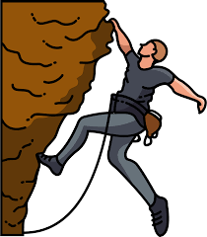

………………………
………………………
………………………
………………………

5- Choose the correct answer.
1- We (donate – newborns – blood ) food to hungry people.
2- Saeed always works on the weekend. He's (a devoted employee - a vegetarian - an exercise freak).
……\ 2 marks

……\ 2 marks
6.Choose the missing letter.
1-The ..ustodian of the Two Holy Mosques, King Salman bin Abdulaziz was born in Riyadh.(C – J - R)
2- The synonym of ( vacation ) is holi…ay. ( f - d - c )

7- write the missing letter



Coac…...
E….ail

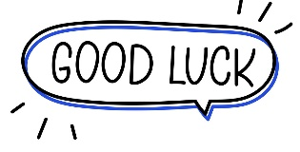

Your teacher:

…………..……………….. Intermediate School

Total

المجموع | تحريري | شفهي
20 | 10 | 10

First Period Exam

Third Intermediate Grade

Name ………………………………… Class ………………………………
__________________________________________________________________________________________
Comprehension

/ 2

Read the following then answer the questions:

Ali has a scooter. His scooter is green. His uncle gave him the scooter on his 9th birthday as a present. Ali loves it so much! Every Saturday, Ali and his brother go to the park nearby their house. He rides the scooter while his brother rides his bike. They have so much fun at the park.
A- Put (√ ) for true or ( ᵡ ) for false :

( ) | 1. On Ali's birthday, his father gave him a gift.
( ) | 2. Ali's brother has a bike.

B- Choose the right answer:

beach | hospital | park | school | 1- At the weekend, Ali goes to the ______
black | red | yellow | green | 2- His scooter is _________ .
___________________________________________________________________
/ 2.5
Grammar

Choose the right answer:

1- She _______ coffee now and then.
A. drink B. drinks C. drinking D. drank
2 - ____ of them are teachers.
A. Both B. Can C. Neither D. Do
3 - Did you live in Riyadh? Yes, I ______ .
A. do B. does C. am D. did
4 - Maybe I_____ stay with friends .
A. am B. have C. am going to D. will
5 - What are you ______ now .
A. do B. doing C. does D. did

/ 2
Vocabulary

A- Choose the best answer to fill in the blank:
1. A ________ diet contains plenty of fresh produce.
D. small | C. fast | B. unhealthy | A. healthy
.2. For teenagers, the ________ is a tool for learning and a means of communication
D. pen | C. computer | B. bag | A. book
3- She never eats meat, She is____________ .
D. shopping | C. devoted | B. slim | A. Vegetarian
4- One suitcase And I have one _______ . .
D. pen | C. plane | B. carry - on | A. bag
B- Put the right word under its picture:
 | 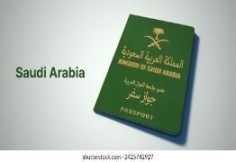 | 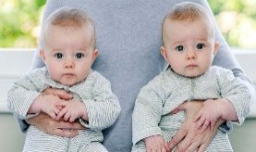 | 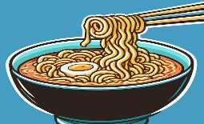 | 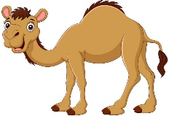
/ 2.5
camel , noodles , passport , shopping , twins

_______________________________________________________________________________
/ 1
Orthography

Choose the correct letter:
r | c | d | 1. He flew aboard the spa_e shuttle Discovery.
v | o | u | 2. He likes to wear fashionable cl_thes.

Good luck T.

Name: ……………………………
Class: 3rd Intermediate Grade
10 /
…….. Intermediate School First Exam - 1448 First Term
- Grammar:
- Choose:
- Rana often (make – makes – making) her bed in the morning.
- Sara and Dana are sisters. (Both – All – Neither) of them are doctors.
- Yara didn’t (send – sends – sent) an email to her friend.
- The restaurant opens (in – on – at) 8 o’clock.

- Do as shown between brackets:
- Ali ate an apple. (Change into passive)
…………………………………………………………
- Maha drinks coffee in the morning. (Use “always”)
…………………………………………………………

- Vocabulary:
- Write the words under the pictures:
blood – newborn – encourage – vegetarian - chat


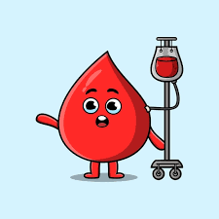
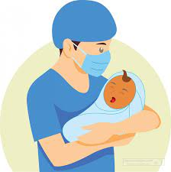

_____________ _______________ ________________ ______________

- Fill in the blank with the correct words in the box:
herbal tea – twin – litter

- My aunt has ……………… daughters.
- I have got some …………………. Let me make you a cup.

- Match:
- exercise freak a- does not interested at all.
- humanitarian b- a person who helps others.
. c- someone who exercise a lot

- Orthography:
- Fill in the missing letters:
- I can’t answer that puzz__e; I give up.
- I've got a dental appo__ntment on Monday.
- She tried her best to sol__e the problem.
- You did an outsta__ding job on the project.

Good Luck
Ms. Tahani Al-Ghamdi

English language
3rd grade intermediate
1st term

intermediate School

Composition
My Trip
Write a paragraph about your trip, Use the information below:
- Where do you want to go?
- What are you going to do while you’re there?
3. When are you going to leave? 4. How long are you going to stay?
5. What airport do you want to leave from? 6. Who is going with you?
7. What kind of hotel do you want to stay at
8. What sights do you want to see?
2 marks structure
2 marks idea
1 mark punctuation
1mark on-off composition
Comprehension
Guide to Egypt Pyramids
When you visit Egypt, there are many exciting things to do around the famous pyramids. You can explore the Great Pyramid of Giza, which is the largest and most amazing of all the pyramids. After seeing the pyramids, you might want to go to the nearby Sphinx, a big statue with a lion's body and a human head. There are also fun places to stay nearby, where you can rest after your adventures. Some hotels have beautiful views of the pyramids, making your visit even more special!

Comprehension
Meal with friends
On a nice day during the weekend, some friends decided to go to their favorite pizza restaurant. When they arrived, a friendly waiter greeted them and showed them to a table. The friends looked at the menu and decided to order a variety of pizzas - chicken pizza, vegetable pizza, and even a seafood pizza.
The pizzas were all tasty and the friends had a wonderful time eating and enjoying their meal together.

30
Name:……………………………………………………
Seat: ………………………………………………………
Mark:

6

1 mark each
8

A/Choose the correct answer:
1. Which animal's body is part of the Sphinx?
a) Elephant b) Lion c) Cat
2. What can you see from some hotels?
a) Mountains b) Pyramids c) Revers
3. What is the Sphinx?
a) Statue b) Hotel c) car
4/Where is the Great Pyramid?
a) In Giza b) In a hotel c) In the desert
B/ Fill in the blanks:
5. The Great Pyramid of Giza is the __ of all the pyramids.
a) smallest b) Largest c) Longest
6. Many __ offer beautiful views of the pyramids.
a) Hotels b) Shops c) Restaurants
C/Put (T) for true or ( F )for false:
7. When you visit Egypt you can see mountains (  )
8. Some hotels have bad views ( )
Grammar
- Choose the correct answer:
I. How often ______ you go out? {do – does – did – doing}
2. Where _____ you go last weekend? {did - doing – does - do}
3. When I was child I______ play with dolls {use to – used to – do – did}
4. Omar is_________ in the pool now. {swimming – swim – swims – swam}
5. The ball rolled ___ from the playground { between – away – off – across}
6.Tom hurt ______ while playing football {himself – herself -itself-themselves}
7. I was late ______ I missed the bus. {because – so – t – such}
8. "I have __________ money to buy the toy." {too – many– enough – any}

1 mark each
8

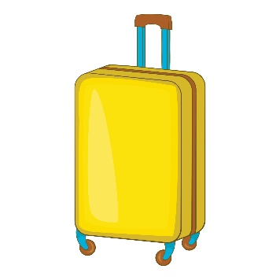
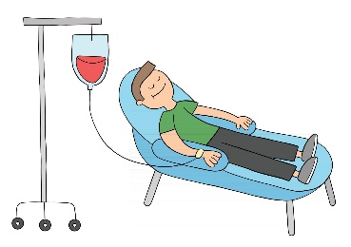
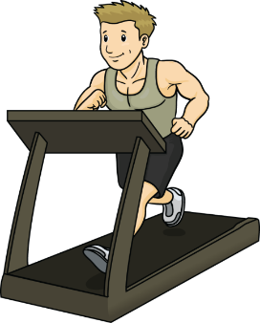
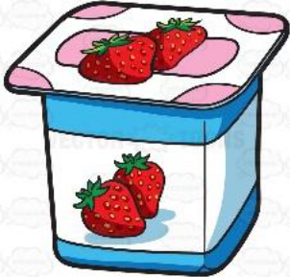
Vocabulary
A-Choose the correct answer:
1 I like drinking ____________ tea. {water – herbal – juice}
2/ The main ingredient of ______is avocado. {guacamole – chicken – pizza}
3/ My sister has two kids, they are__________ { parents – friends – twins}
4/ She never eats meat she is ____________. {vegetarian – diet – athlete}
B-Match the word with its meaning:
- metropolis | 2 | Special
- unique | 3 | Repeat from memory
- recite | 4 | donation
- charity | 1 | Big city

Choose the missing letter:
1/ t_ins ( s – w– k)
2/ buz_ing (z– k – d)
3/ _ogurt ( n– m – Y)
4/ addic_ ( t– p– u)
Write the correct word under each picture:
{Suitcase / work out / blood donation / Yogurt}
Yogurt | work out | blood donation | Suitcase

With my best wishes
Manal Al- Alshareef
Half mark each
8

