1
1– What animals are now extinct?

1. CHOOSE
A. Butterflies. B. Dinosaurs
2– What activities are part of your lifestyle?

A. Exercise and healthy eating. B. I am very happy.
المملكة العربية السعودية |  |  | اسم الطالب/ ......................................
وزارة التعليم
إدارة التعليم بمنطقة |  |  | المادة : انجليزي
مدرسة : |  |  | الزمن :
 |  |  | الصف : السادس فصل ( )
شفهي | تحريري |  |  | المجموع
10 / | 10 / |  |  | 20 /
Top goal3 اختبار الفترة الأولى الفصل الأول - للعام الدراسي 1448– لغة انجليزية –– للصف السادس
اسم الطالب / هـ الفصل /

2. CHOOSE OR
1.5

She has longer hair.
Be quiet.
This is an elbow.

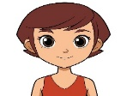

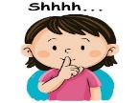
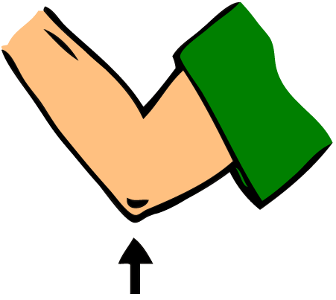

3. DO AS SHOWN BETWEEN BRACKETS
1.5

1- Sharks eat fish. (complete ) ___________ are eaten by _____________.
spoon | bed | tissue | 2 – I use _______ to eat food ( choose )
4. CHOOSE
1

are fed | Is feed | 1. Cats ________ by humans.
passed | will pass | 2- you _______ your exam, if you study hard

3
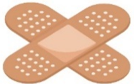 | 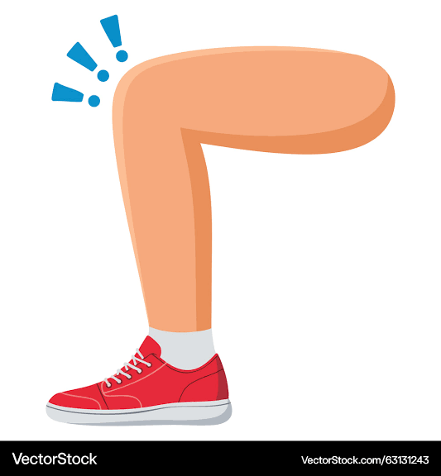 | 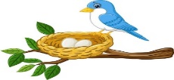 | 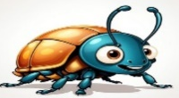 | 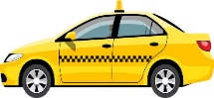 | 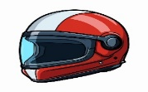  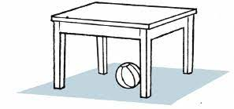
bandage | finger | nest | butterfly | taxi | helmet
medicine | knee | net | beetle | plane | cap
5. CHOOSE
5. CHOOSE
2

Choose the correct letter: ( k - r - g - d ) )

سادس

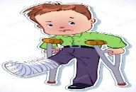 | 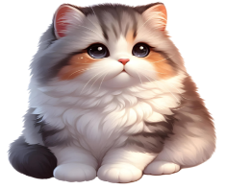 | 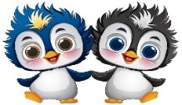 | 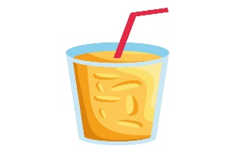
Bro_en leg | The f_r is very soft. | look l_ke | A _lass of juice
c | u | i | g
k | e | u | c

___________________________________________________________________________________________________________________________________________________________________________________________________________________________________
Controlled writing

4

Good luck T.


Kingdom of Saudi Arabia 6th Elementary Grade

Ministry of Education First Term

10
……… Elementary School First Exam - 1448 AH
Name: ………………………………………………………….………………. Class : …………..
- General Questions:
- Choose the correct answer:
1- When something can happen, but not right now.
a- if you want |  |  |  |  | a- in a minute
2- What do you do as a zoologist?
a- I study and look after animals. |  |  |  |  | b- I study and look after cars.
3- Name an animal that lives underwater and has eight legs.
a- A shark. |  |  |  |  |  | b- An octopus.
- Reading short sentence:
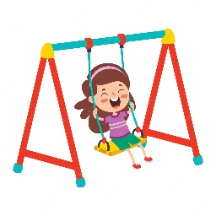
- Read the sentences then match them with the correct pictures:
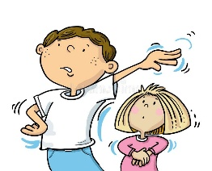 | 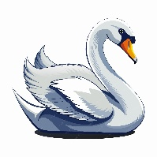 | 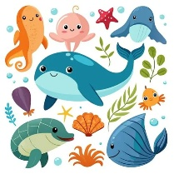
a-_Go away!  b-_Yes! I agree! | a- It is a frog.  b- It is a swan. | a-They live in the ocean.  b-They live in the desert. | a-_She is on the swing.  b-_She is climbing a tree.

III. Grammar:
- Choose the correct answer:
- The jungle ………………. tigers hunt.
- am where |  |  | - is where |  |  |  |  | - are where
- Dinosaur bones are ………………… by scientists.
- study |  |  | - studied |  |  |  |  | - studying
- What did you …………………. for breakfast this morning?
- eat |  |  | - ate |  |  |  |  | - eating
V. Vocabulary:
- Choose the correct answer:
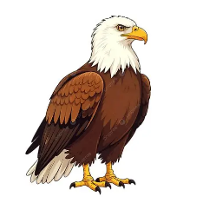 |  | 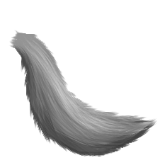 |  |  |  | 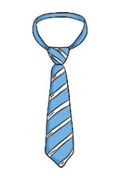 |  |  | 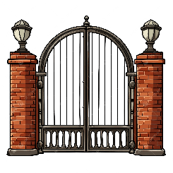
- eagle  - chameleon |  | - wing  - fur |  |  |  | - tie  - backpack |  |  | - gate  - glass
- Fill in the blanks with the words from the box.
agree – at the moment – pond
1- ………………………: Another way to say “right now”.
2- ………………………: a small area of water where fish live.
VI. Orthography:
- Choose the correct missing letters:
  jour__alist |  | 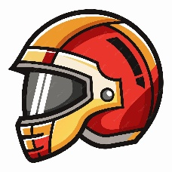  h__lmet |  |  |  | 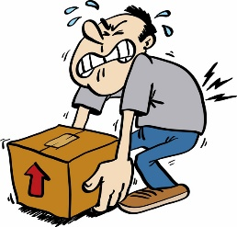  hea__y |  |  | 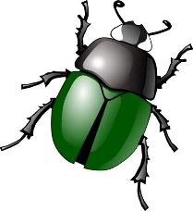  bee__le
m | n | i |  | e |  | v | f |  | t | d

BEST OF LUCK
Ms. Tahani Al-Ghamdi



First Period Exam – Top Goal 3

مدرسة :
الاسم | الفصل | شفهي | تحريري | المجموع
 | / | 10 / | 10 / | 20 /
Choose the correct answer:
/ 1
1– What animals are now extinct?

A. Butterflies. B. Dinosaurs
2– What activities are part of your lifestyle?

A. Exercise and healthy eating. B. I am very happy.

____________________________________________________________________________________________________
Choose or :
/ 1.5
It is a big dinosaur. |  | She has a long hair. | This is an elbow .
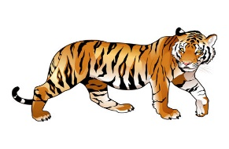 |  | 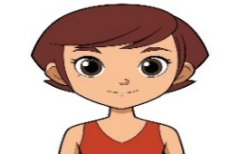
______________________________________________________________________
/ 1.5
1- Sharks eat fish. (complete ) ___________ are eaten by _____________.
spoon | bed | tissue | 2 – I use _______ to eat food ( choose )
Do as shown between brackets :

Choose the correct word:
/ 1
are fed | Is feed | 1. Cats ________ by humans.
passed | will pass | 2- you _______ your exam, if you study hard

/ 3
Choose the correct word:

bandage | finger | nest | butterfly | taxi | helmet
medicine | knee | net | beetle | plane | cap
Choose the correct letter to fill in the blank:
/ 2
Bro_en leg | The f_r is very soft. | look l_ke | A _lass of juice
c | u | i | g
k | e | u | c

Good luck T.
Controlled writing

4

