

English Language

Intermediate Grade 3rd

1st period Exam

Kingdom of Saudi Arabia

Ministry of Education

………………… School

[](https://t.me/Asmaworld)

Student's Name : class:

……\ 5 marks

1-Read the following passage and answer the questions below:

Saudi Arabia is the is the largest country in West Asia and the thirteenth largest in the world. It's population is about 27 million and the official language is Arabic. Riyadh is the capital city and it's the largest city in Saudi Arabia. The kingdom tower is the tallest skyscraper in Riyadh and the 26th tallest building in the world. Jeddah is the largest city on the red sea.

|  |  |  |
| --- | --- | --- |
| 1-What is the largest country in West Asia? | | |
| c- Oman | b- Kwiat | a- Saudi Arabia |
| 2-. It's population is about ……………. million | | |
| c-27 | b-31 | a-45 |
| 3-…………… is the capital city and it's the largest city in Saudi Arabia. | | |
| c-Jeddah | b- Riyadh | a-Dammam |
| 4-What's the official language in Saudi Arabia? | | |
| c-French | b-English | a-Arabic |
| 5- The Kingdom Tower is the…………..tallest building in the world. | | |
| c- 14th | b-26th | a- 30th |

**2-choose the correct answer.**

……\ 5 marks

|  |  |  |  |
| --- | --- | --- | --- |
| c- an | b- a | a-the | 1- I read ……… Holy Quran everyday . |
| c- tallest | b- taller | a- tall | 2- Ali is ………than Ahmad |
| c- playing | b- played | a-play | 3- I have …………football since I was 10. |
| c-to | b-since | a- for | 4-Hameed has had the same TV …..15 years. |
| c- best | b-good | a-better | 5- Jake gets the ……… grade in the class. |
| c- known | b- knows | a- know | 6- How long has Ali ………..his friend? |
| c- smartest | b- smart | a- smarter | 7- you are as ……… as your brother |
| c- eaten | b-ate | a- eat | 8- The fish has been …………by the cat. |
| c-an | b-the | a-a | 9- When….. sun goes down ,you can see the moon |
| c- studying | b- studied | a- study | 10- She has …….. English for five years. |

……\ 2 marks

**3. Do as shown between brackets.**

**Use (How long)**

a-Omar / go / to this dentist

……………………………………………………………………………………………………..?

**(make indirect question)**

a-Where is the main post office?

……………………………………………………………………………………………………..?

……\ 6 marks

**A -Choose the correct answer.**

1-( doctor - pilgrim - teacher ) is a person who travels to a holy place.

2- A ( Policeman – Filmmaker – Writer )is someone who controls the making of a film.

3- aspects means :( getaway – features – classes )

4- An area on the edge of a large town or city( suburb – ocean – desert )

**B-Match the correct word for each picture. (credit card - printer - bridge skyscrapers )**

**)**

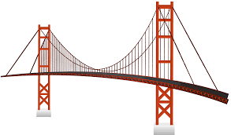

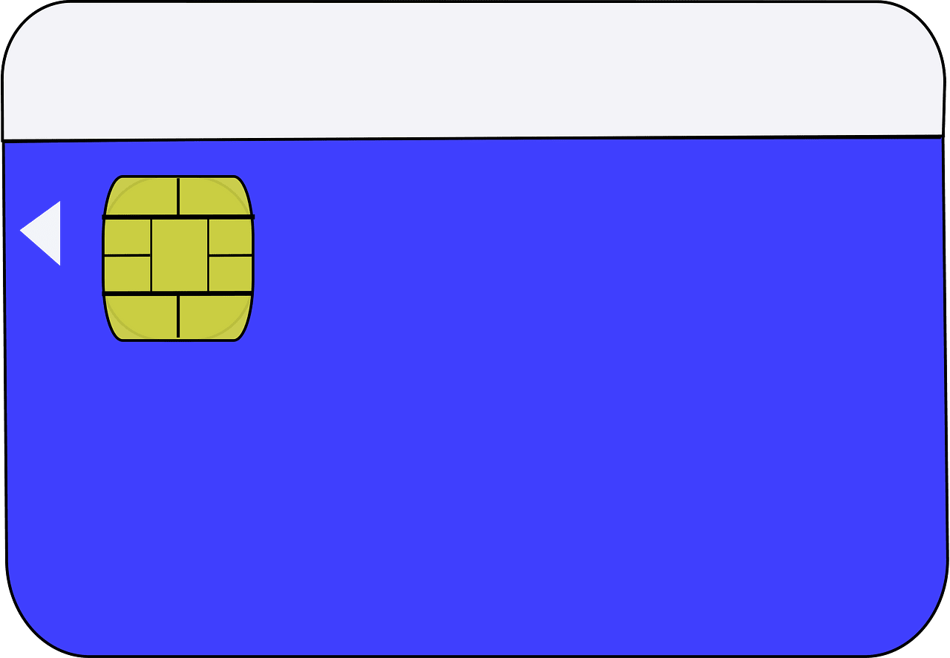

………………..

………………..

………………..

………………..

**A-choose the missing letters**

……\ 2 marks

1- lap…ops have become smaller and lighter. ( d – h – t)

2- The kin…dom tower will be the world’s tallest building.( f- g – y )

**B-write the missing letter**

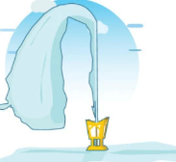

1-Paper cli…

2-fou….tain

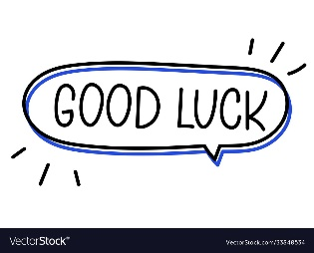

Your teacher:

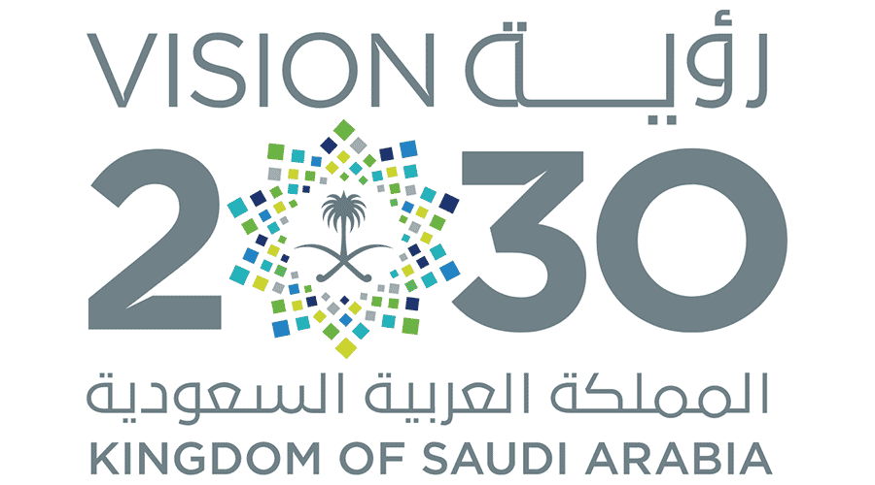

**Kingdom of Saudi Arabia**

**Ministry of Education**

**………… Education Directorate............**

**…………..……………….. Intermediate School**

|  |
| --- |
|  |
| **20** |

**Total**

**Midterm Test**

|  |
| --- |
| **Third Intermediate Grade** |

**Name ………………………………… Class ………………………………**

__________________________________________________________________________________________

/ 5

**Comprehension**

**Read the following then answer the questions:**

Saad is interested in Geography books. He has already read many books about India,  
Indonesia, Bangladesh and Japan. Saad visits the school library almost every day where he can read a lot of Geography books. Last week, Saad wrote a very good note in the school Magazine and the headmaster was happy to read that note. He gave him some books as a present.

**A- Put (√ ) for true or ( ᵡ ) for false :**

|  |  |
| --- | --- |
| **( )** | **1.**  Saad read many books about Pakistan. |
| **( )** | **1.**  Saad visits the school library almost every day. |
| **( )** | **2.**  The headmaster gave him some money as a present. |

**B- Choose the right answer:**

|  |  |  |  |  |
| --- | --- | --- | --- | --- |
| **English** | **History** | **Math** | **Geography** | 1. Saad is interested in ________ books . |
| **father** | **headmaster** | **student** | **teacher** | **2-** The ____ was happy to read his note. |

_____________________________________________________________________________________________________

/ 5

**Grammar**

**A-Choose the right answer:**

|  |
| --- |
| **1.**  I ____ there two years ago.  **A . am B. were C. have D. was** |
| **2.**  He ______ studied English since third grade.  **A . was B. has C. have D. is** |
| **3.**  Trains are ______ than buses**.**  **A . big B. fastest C. fast D. faster B-Do as shown between brackets:**  **1.** I have played football**______** three years. **( Choose ) [since / for]**  **( Choose ) [the / a ] 2-** You can see ___ moon in the sky . |

**Vocabulary**

/ 3

**A- Choose the best answer to fill in the blank:**

|  |
| --- |
| **1.** I flew on a ______ on my vacation. |
| **A. car B. bus C. taxi D. plane** |
| **2**. She cooked the pizza on the _____. |
| **A. shower B. stove C. printer D. washer** |
| **3-** The apartment was a bit run down, so I had to _________ it. |
| **A. renovate B. clean C. wash D. recycle** |

**B- Put the right word under its picture:**

|  |  |  |  |
| --- | --- | --- | --- |
| Premium Vector | Black and white drawing of a modern train | 250+ Spaghetti Black And White Stock Illustrations, Royalty-Free Vector  Graphics & Clip Art - iStock | Vintage pasta | Bowl Microwave Icon Outline Bowl Microwave: เวกเตอร์สต็อก  (ปลอดค่าลิขสิทธิ์) 1849606075 | Shutterstock | Vector Image Of A Hand Holding A Camera 22824211 Vector Art at Vecteezy |
|  |  |  |  |

/ 4

**Microwave - Pasta – Camera – Train**

_______________________________________________________________________________

/ 3

**Orthography**

**Choose the correct letter:**

|  |  |  |  |
| --- | --- | --- | --- |
| C**. ( o )** | B**. ( u )** | A**. ( c )** | 1. They are watching televisi__n . |
| C**. ( c )** | B**. ( s )** | A**. ( t )** | 2. Let’s play tenni__ after lunch . |
| B**. ( v )**  C**. ( l )** | | A**. ( r )** | 3**.** Saudi Arabia has many natural resou__ces . |

Good luck T.



English Language

Intermediate Grade 3rd

period Exam

………\20

Kingdom of Saudi Arabia

Ministry of Education

………..Education Directorate

………………… Intermediate School

Student's Name : class:

**Reading comprehension ✦**

[](https://t.me/Asmaworld)

……\ 5 marks

1-Read the following passage and answer the questions below:

The Arab world is located in two continents Asia and Africa. The region offers a variety of climatic conditions as we have mountains with snowy weather and the desert with hot and dry one so farming is very important to people there, some of the main products are wheat, dates, rice and olive oil. The Arab world is also famous for its rich culture like Ancient Egypt. The Arab culture was very powerful in art, science, architecture and writing.

|  |  |  |
| --- | --- | --- |
| 1- The Arab world is located in two continents Asia and ……… | | |
| c- Africa | b- Europe | a- Australia |
| 2- A place with little water, plants and animals | | |
| c- school | b- sea | a- desert |
| 3- The opposite of cold ≠ ………… | | |
| c- happy | b- hot | a- big |
| 4- There are many crops that farmers grow like wheat and ………. | | |
| c- dates | b- mango | a- papaya |
| 5- The Arab culture was very powerful in ……, science, architecture and writing. | | |
| c- engineering | b- business | a- art |

**A. Choose the correct answer.**

1- Ali is ( tall – taller – tallest ) than Ahmad.

2- She has ( study – studied – studying ) English for five years.

3- you are as ( smart – smarter – smartest ) as your brother.

4- Hameed has had the same TV ( for - since – to )15 years

5- The fish has been ( eat -eaten -ate )by the cat.

6- I read ( a – an – the ) Holy Quran everyday

7- How long has Ali ( know – knows- known )his friend?

8- Jake gets the ( good – better – best ) grade in the class.

**Grammar**  ✦

……\ 4 marks

**B. Do as shown between brackets.**

**1-Use (How long)**

a- Omar / go / to this dentist

…………………………………………………..……………………………………………………..?

……\ 1 marks

 **2-change into passive.**

……\ 3 marks

a- The boys broke the window.

. …………………………………………………………………………………………………..

**3-(make indirect question)**

a-Where is the main post office?

……………………………………………………………………………………………………

**4- Use ( as ……….as )**

Rome is an amazing city, Paris is an amazing city .

……………………………………………………………………………………………………

……\ 5 marks

✦  **Vocabulary**

**A.Match the correct word for each picture.**

printer skyscrapers coast microwave





………………..

………………..

………………..

………………..

**B- choose the correct answer.**

**1-** a person who travels to a holy place ( pilgrim - pilot – engineer )

**2-** an area on the edge of a large town or city ( continent - suburb – ocean )

**✦ Orthography**

**Choose the corre**

……\ 2 marks

**A-Choose the correct missing letters.**

1-Cell p…ones are very small today ( h – l – k )

2- One of the Jeddah’s major landmarks is King Fahd’s …ountain. ( F – J – L )

3-The apartment is really nice and co…y. ( a – z – p)

4-Tele..ision has been around for a long time.( x – o – v )

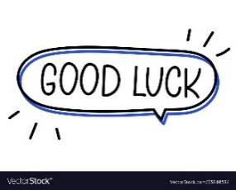

Your teacher …..:…………………………….