[](https://t.me/Asmaworld)

English Language

2nd secondary Grade

period Exam

…………….\10

Kingdom of Saudi Arabia

Ministry of Education

…………… secondary school

Student's Name : class:

……\ 2 marks

**1-Read the passage then answer the questions:**

We cannot live without the sun’s heat or the air that we breathe, but these givers of life can also become dangerous killers. Moreover, they can behave even more dangerously when they are combined with another great natural force: water. The largest and most destructive results of this are hurricanes. These huge storms can hit land so powerfully that they destroy everything in their path. Information is therefore collected from space satellites.

|  |  |  |
| --- | --- | --- |
| 1-Name the three things in nature that combine to produce hurricanes. | | |
| c- sun's heat ,air and trees | b- sun's heat ,air and mountains | a- sun's heat ,air and water |
| 2- How hurricane forecasters get their information? | | |
| c- radio | b-News  **Grammar** | a- space satellites |

**A.choose the correct answer:**

1- It is important that you ( brush _ brushes – brushing ) your teeth.

2- It was apart time job, ( isn't – wasn't – doesn't ) it ?

3-You ( must – had to – need to ) stop at " STOP " sing.

4- If you heat the water to 100 Cº , it ( boil – boils – boiling ).

**B-Do as shown between brackets.**

**1-(correct)**

a- We decide to **gets** good marks. ………

b- Would you mind **tell** me where the supermarket is?....................

**2-( reorder)**

a- could \ me \ you \ help \ ? ………………………………………………………………………

……\ 4 marks

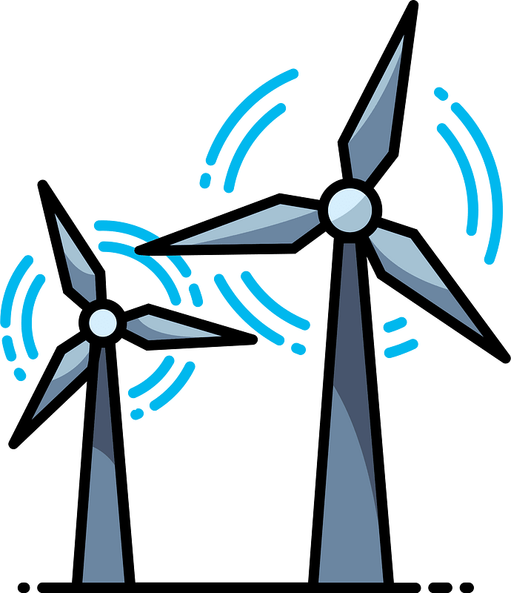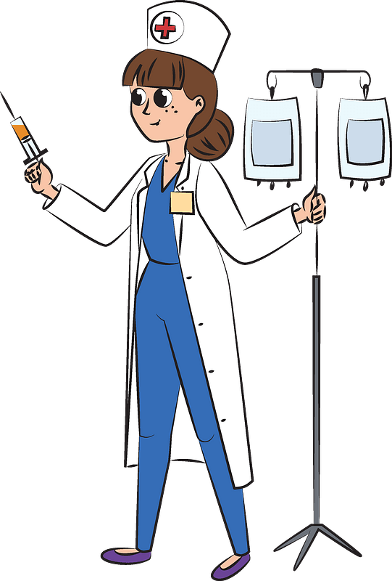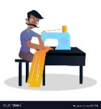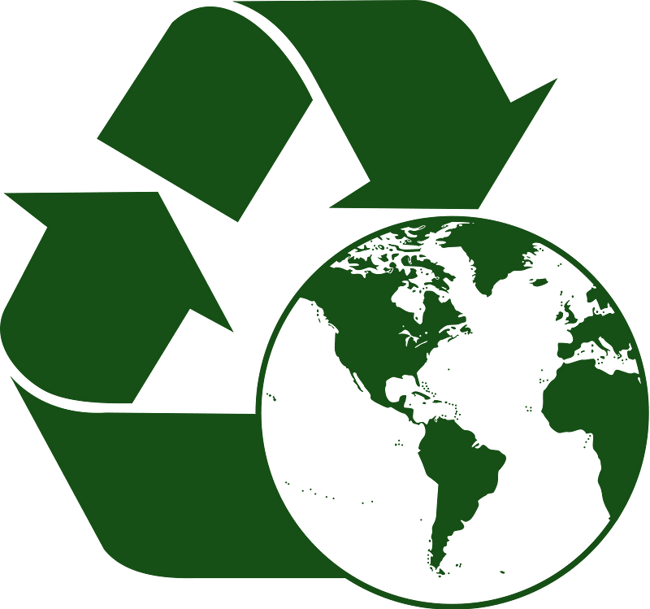

……\ 4 marks

**Vocabulary**

Your teacher:

……………………….

……………………….

……………………….

……………………….

**C-write the correct word under each picture.** ( **tailor – recycle- nurse – turbines )**

**B.Find the odd words.**

1- wood glass plastic

2- fashion fabric window

2-

**A-Complete the sentences with these words:** (organic veterinarian pesticides)

1-………………. Food is produced entirely without chemicals.

2-………………………………is a doctor for animals.