|  |  |  |  |  |  |  |  |  |  |  |  |  |  |  |
| --- | --- | --- | --- | --- | --- | --- | --- | --- | --- | --- | --- | --- | --- | --- |
| **Distribution of the syllabus We Can 2 - Second Term 1446 2nd Grade** | | | | | | | | | | | | | | |
| **4th week** | | | **3rd week** | | | | **2nd week** | | | **1st week** | | | **today** | |
| **Friends, Actions, Things**  **P 10**  **P 11** | **7/6** | **Beautiful Nature**  **Revision**  **Evaluation Unit 1** | | **29/5** | | **Beautiful Nature**  **P 4 , 5**  **P 6 , 7**  **P 8 , 9 , 34** | | **22/5** | **Beautiful Nature**  **P 2**  **P 3** | | **15/5** | **Sun** | | |
| **8/6** | **1/6** | | **23/5** | **16/5** | **Mon** | | |
| **9/6** | **2/6** | | **24/5** | **17/5** | **Tue** | | |
| **إجازة مطولة** | **10/6** | **3/6** | | **25/5** | **18/5** | **Wed** | | |
| **11/6** | **4/6** | | **26/5** | **19/5** | **Thurs** | | |
| **8th week** | | | **7th week** | | | | **6th week** | | | **5th week** | | | **today** | |
| **اجازة منتصف الفصل الثاني** | **/75** | **Wild Animals**  **P 18 , 19**  **P 20 , 21**  **P 22 , 23 , 35** | | **28/6** | | **Friends, Actions, Things**  **Revision**  **Evaluation Unit 2** | | **21/6** | **Friends, Actions, Things**  **p 12 ,13**  **p 14 ,15**  **p 16 ,17** | | **14/6** | **Sun** | | |
| **6/7** | **29/6** | | **22/6** | **15/6** | **Mon** | | |
| **7/7** | **30/6** | | **23/6** | **16/6** | **Tue** | | |
| **8/7** | **1/7** | | **24/6** | **17/6** | **Wed** | | |
| **9/7** | **2/7** | | **25/6** | **18/6** | **Thurs** | | |
| **12th week** | | | **11th week** | | | | **10th week** | | | **9th week** | | | **today** | |
| **Food**  **P 32 , 33**  **Phonics Practice p 39**  **Evaluation Unit 4** | **3/8** | **Food**  **P 30**  **P 31**  **Phonics Practice p 38** | | **26/7** | | **From Here to There**  **P 26 , 27**  **P 28 , 29**  **Phonics practice p 37** | | **19/7** | **Wild Animals**  **P 24 , 25**  **Evaluation Unit 3** | | **12/7** | **Sun** | | |
| **4/8** | **27/7** | | **20/7** | **13/7** | **Mon** | | |
| **5/8** | **28/7** | | **21/7** | **14/7** | **Tue** | | |
| **6/6** | **29/7** | | **22/7** | **15/7** | **Wed** | | |
| **7/8** | **30/7** | | **23/7** | **16/7** | **Thurs** | | |
|  | | | **14th week** | | | | |  | | **13th week** | **Date** | | **today** | |
| شعار وزارة التعليم مع الرؤية 2030 ” نماذج مفرغه وشفافه “ | المرسال | | | **Final exams** | | | | | **8/17** | | **End of the continuous evaluation**  **Remedial Plan** | **8/10** | | | **Sun** |
| **18/8** | | **11/8** | | | **Mon** |
| **19/8** | | **12/8** | | | **Tue** |
| **20/8** | | **13/8** | | | **Wed** |
| **21/8** | | **14/8** | | | **Thurs** |
| **Headmaster:** | | | | | **Supervisor:** | | | | | **Teacher:** | | | | |
|  | | | | |  | | | | |  | | | | |



**المملكة العربية السعودية**

**وزارة التعليم**

**الإدارة العامة للتعليم بمنطقة**

**مكتب تعليم**

**ثانوية نجد**

**المدرسة:**

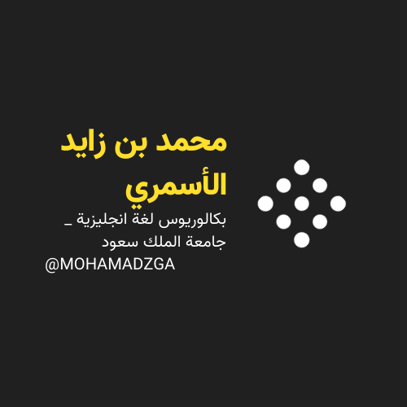

** قناتي**



**M_zaid0 MOHAMADZGA**

**لا تنسوني من صالح دعائكم**