|  |  |  |  |
| --- | --- | --- | --- |
| **المملكة العربية السعودية**  **وزارة التعليم**  **الإدارة العامة للتعليم بـن مدرسة م ن الابتدائية** | http://tabuk2day.com/wp-content/uploads/IMG_3362.jpgبسم الله الرحمن الرحيم **اختبار الفصل الدراسي الثاني**  **للعام الدراسي 1444 هـ** | **المادة** | **لغة انجليزية** |
| **الصف** |  |
| **الزمن** | **ساعة ونصف** |
| **الفصل** | **-----** |
| **اسم الطالب رباعيا: ............................................................................................................رقم الجلوس:....................**   |  |  |  |  |  |  |  |  | | --- | --- | --- | --- | --- | --- | --- | --- | | **السؤال** | **1** | **2** | **3** | **4** | **5** | **6** | **المجموع** | | **الدرجة** |  |  |  |  |  |  |  | | **الدرجة** | 6 | 5 | 4 | 5 | 6 | 4 | 30 | | **المصحح** |  |  |  |  |  |  |  | | | | |

**I- General Questions:**

**https://t.me/abokhaledamer**

**6**

**Q1: A- Choose the correct answer:**

**1. Look. It’s a flower.**

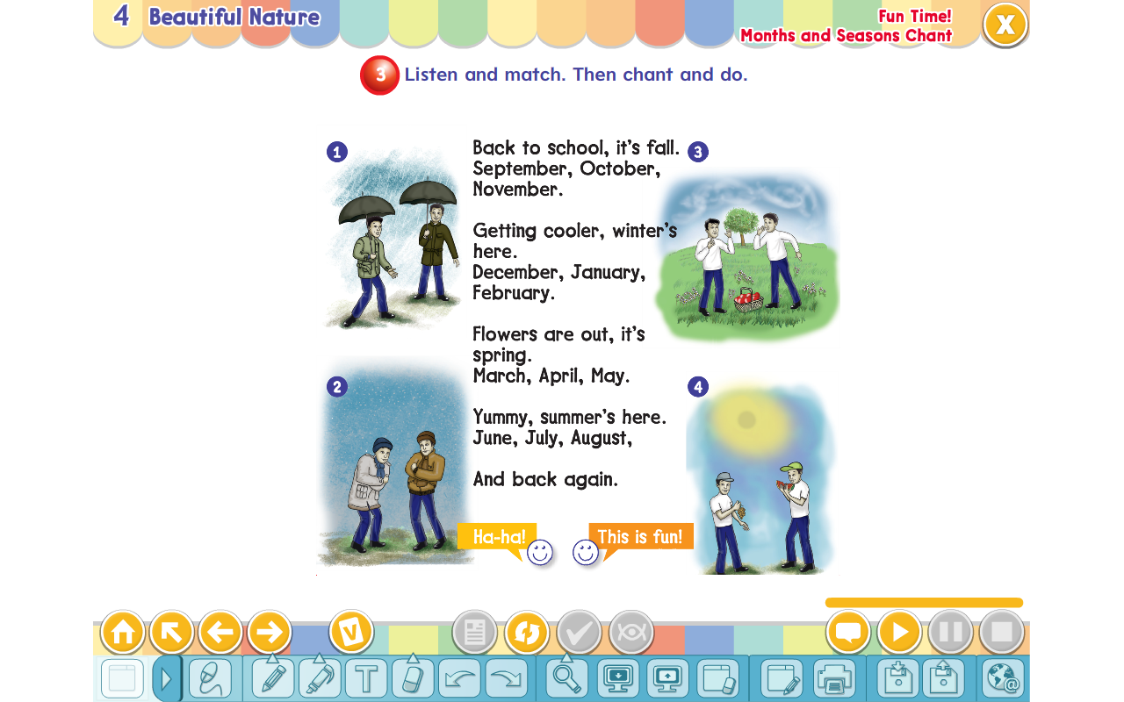( It’s ugly. – It’s beautiful. – It’s bad. )

**2. What’s the weather like in winter?**

( It’s cold. – It’s sunny. – It’s hot. )

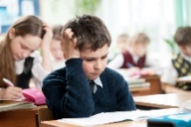

**3. Where is Ali?**

( He’s at school. - He’s tall. – He’s eating. )

**B- Match the questions in column (A) with the correct answers in column (B):**

|  |  |
| --- | --- |
| **B** | **A** |
| **( ) by the tail.**  **( ) Walk straight then turn left.**  **( ) It’s over there.** | **1. Where’s the lion? 2. I will catch a tiger 3. Where is the train station?** |

**5**

**II- Controlled Writing:**

**Q2: Do as shown between brackets:**

**1. go – How – you – to – do – school? (Rearrange)> ________________.**

**2. have – Elephants – trunks – big (Rearrange)> _______________.**

**3. Is he playing football? (Answer)> _______________________.**

**4.January, _____________, March. (Complete)>**

**5. When you see red light, _____________. (Complete)**

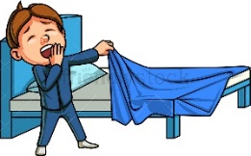**III- Reading Short Sentence:**

**4**

**Q3: Match the sentence with the pictures:**

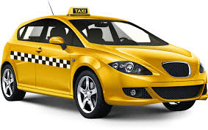**1. I love the mountains.**

**2. Let’s go to bed.**

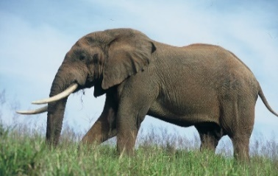**3. Look. It’s an elephant.**

**4. I go to the airport by taxi.**

**IV- Grammar:**

**5**

**Q4: Choose the correct answer:**

**1- Excuse me. (Why – When – Where) is the hospital?**

**2- Chimpanzees (am – is – are) smart.**

**3- That is (a – an – at) octopus.**

**4- I have breakfast (in – on – at) the morning.**

**5- The word “cats” is pronounced as ( Z – S – IZ )**

**6**

**V- Vocabulary:**

**Q5: Write the number under picture:**

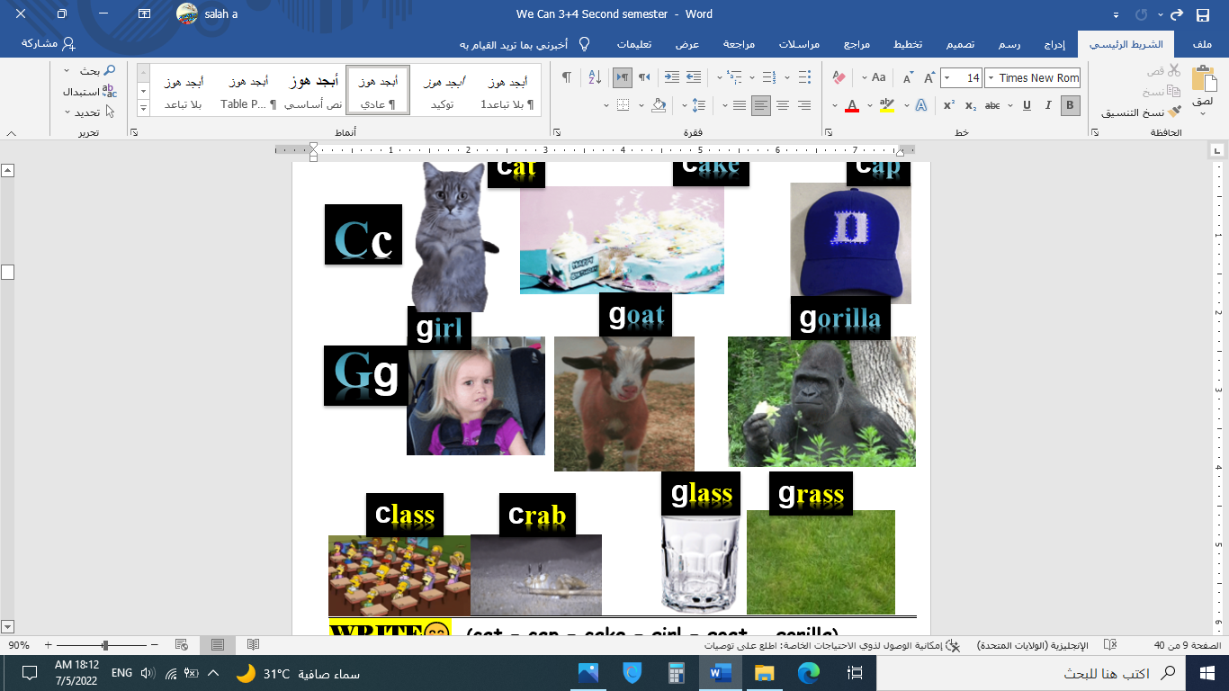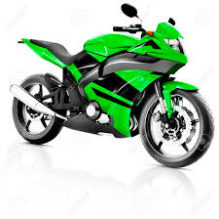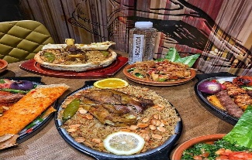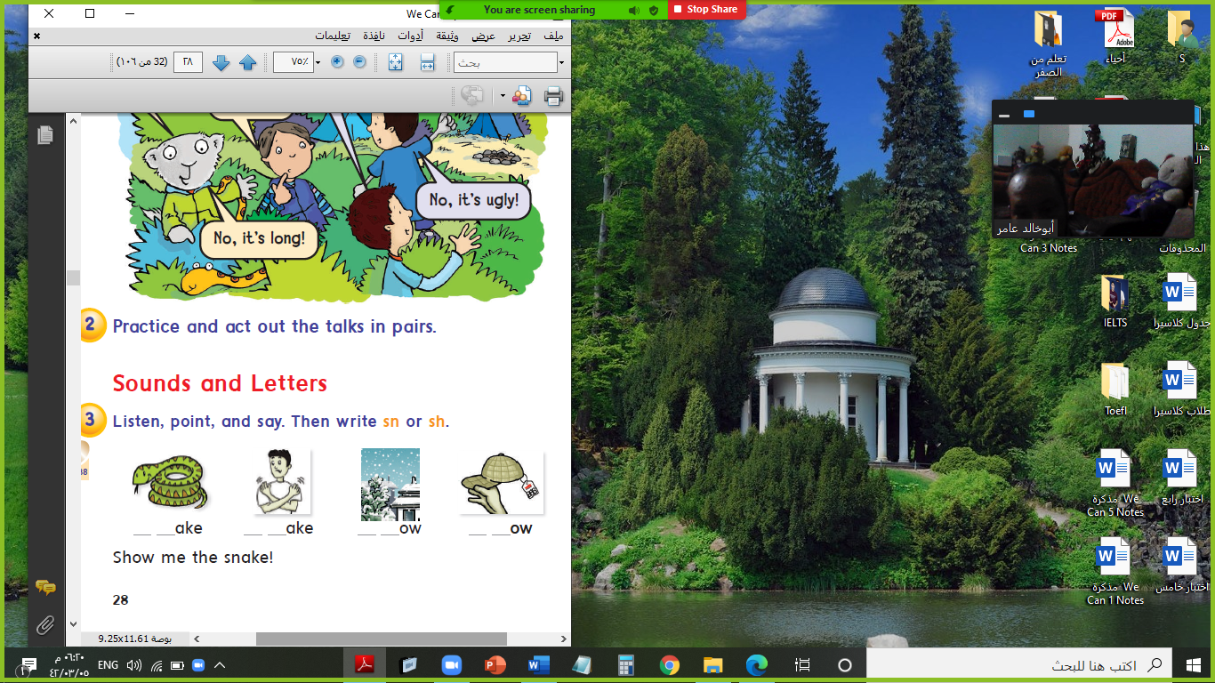**1.motorbike 2.lunch 3.snake 4.gorilla 5.night 6.class**

**( ) ( ) ( ) ( ) ( ) ( )**

**VI- Orthography:**

**4**

**Q6: Fill in the missing letters:**

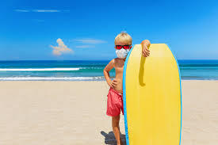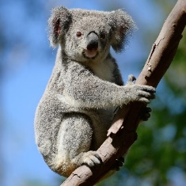**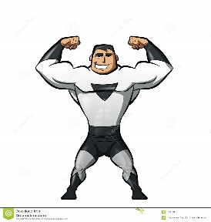****c / e / o / u / r / t / u / a**

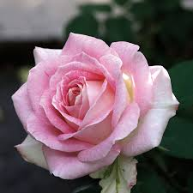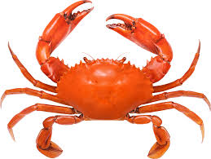

**r__se b__s s__mmer ko__la s__rong m__at c__ab __ake**

**End of Questions**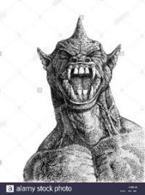

**ABOKHALEDAMER**

**0557325813**