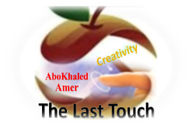**المملكة العربية السعودية**

**Kingdom of Saudi Arabia**

**Ministry of Education**

**------- Educational Directorate**

**------- Future Educational Schools**

**2nd Grade High School 2022**

**2nd Term – Final Exam**

**وزارة التعليم**

**الإدارة العامة للتعليم بن**

**مدارس م ن التعليمية**

**الصف الثاني الثانوي**

**الاختبار النهائي للفصل الدراسي الثاني1444هـ**

|  |  |  |  |  |  |  |  |
| --- | --- | --- | --- | --- | --- | --- | --- |
| **Total**  **written** | **5**  **Vocabulary** | **4**  **Grammar** | **3**  **Free Composition** | **2**  **Guided Composition** | | **1 Comprehension** | **Q. NO.** |
|  |  |  |  |  | |  | **Mark Given** |
| **30** | **6** | **6** | **6** | **6** | | **6** | **Mark** |
| **6** | | | **Reviser** | |  | | **Corrector** |
|  | |

**زمن الاختبار: 3 ساعات**

**اسم الطالب: ------------------------------------ رقم الجلوس: ------------- الصف الثاني الثانوي**

**1.Comprehension**

**Read the following passage then answer the questions**

**Water is life and the lack of water means death. Any living thing cannot go on living without water. Plants need water to grow. Animals need water to drink. People need water to drink and to use in cleaning, cooking, farming and irrigating their lands. We can get water from rivers and lakes. But the main source of water is the rain.  In the desert, people dig deep wells to get water. For keeping water from being wasted, people build dams for storing water in reservoirs that form behind the dams. Water is stored in water towers that supply all the houses with pure water. Our government has set up desalination plants for treating seawater and removing the salt. Thanks be to God, the Merciful, who has created water for us. We don't need to pay for it as it is neither sold nor bought.**

**A) Answer the following questions:  
1. What does the lack of water mean?** ----------------------------------------.

**2. Why do people need water?** ------------------------------------------.

**3. What is the main source of water?**  ------------------------------------------.

**4. Who has created water for us?** -------------------------------------------.

**B) Put ( √ ) or ( X ):**

**5. Water is life and the lack of it means death. ( )**

**6.We cannot get water from rivers and lakes. ( )**

**7. We don't need to pay for it as it is neither sold nor bought. ( )**

**8. Water is stored in water towers that supply all the houses with pure water. ( )  
C) Complete:  
9. We can get pure water from** --------------------------.

**10. A reservoir is formed** --------------------- **a dam:**

**D) Choose the correct answer:**

**11. Plants need water to (**wash – grow – remove – read**).**

**12. In the (**farms – deserts – cities – skies**), people dig deep wells for getting their water.**

**2) Guided Composition**

**6**

**There is no place like home**

**Write a paragraph about "Your Dream Home" in which you describe which kind of**

**home you want to live in, where, who live with…**

-------------------------------------------------------

-----------------------------------------------------------------------------------------------------------------------------------------------------------------------------------------------------------------------------------------------------------------------------------------------------------------------------------------------------------------------------------------------------------------------------------------------------------------------------------------------------------------------------------------------------------------------------------------------------------------------------------------------------------------------------------------------------------------------------------------------------------------------------------------------------------------------------------------------------------------------------------------------------------------------------------------------------------------------------------------------------------------------------------------------------------------------------------------------------------------------------------------------------------------------------------------------------------------------------------------------------------------------------------------------------------------------------------------------------------------------------------------------------------------------------------------------------------------------------------------------------------------------------------------------------------------------------------------------------------------------------------------------------------------------------------------------------------------------------------------------------------------------------------------------------------------------------------------------------------------------------------------------------------------------------------------------

**3) Free Composition**

**6**

**Choose one topic from the following to write about:**

**1. “Pollution” is a serious problem that we should try to eliminate.**

**2. Write a paragraph about "Your Favorite Sport"**

-------------------------------------------------------

---------------------------------------------------------------------------------------------------------------------------------------------------------------------------------------------------------------------------------------------------------------------------------------------------------------------------------------------------------------------------------------------------------------------------------------------------------------------------------------------------------------------------------------------------------------------------------------------------------------------------------------------------------------------------------------------------------------------------------------------------------------------------------------------------------------------------------------------------------------------------------------------------------------------------------------------------------------------------------------------------------------------------------------------------------------------------------------------------------------------------------------------------------------------------------------------------------------------------------------------------------------------------------------------------------------------------------------------------------------------------------------------------------------------------------------------------------

**4) Grammar**

**6**

**A: Choose the correct answer:**

**1. It is important that you (** played – plays – play – playing **) well.**

**2. I enjoy (** watch – to watch – watches – watching **) TV.**

**3. I have two (**large brown wooden – brown large wooden – wooden brown large**) tables.**

**4. The film was** (too – enough – to – that**) boring to watch so we left the cinema early**

**5. (** Reading – Read – Reads – Readed **) is my favorite hobby.**

**6. Who is the (** good – better – best–most **) football player you’ve ever seen?**

**B- Do as shown between brackets:**

**1. this afternoon – I want you – the report – to finish (**Unscramble**)**

------------------------------------------------------------------------.

**2. to reuse – plastic – Don’t forget – containers** **(**Unscramble**)**

---------------------------------------------------------------------.

**3. I bought (yellow – big – Japanese – expensive) car. (**Reorder the adjectives**)**

---------------------------------------------------------------------.

**4. She is tall to play basketball. (**Use**: enough)**

-----------------------------------------------------------------.

**5. It is interesting to play tennis. (**Rewrite using **“Gerund")**

---------------------------------------------------------------------------.

**6. Nora is the most beautiful girl I (meet).**  (Correct in present perfect)

----------------------------------------------------------------------------.

**5) vocabulary:**

**6**

**A- Match the words with the pictures:**

**1.marathon 2.grid 3.surgeon 4.mortar 5.grocireies 6.Olympics**

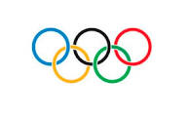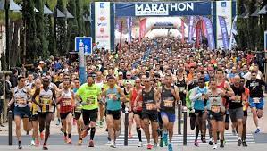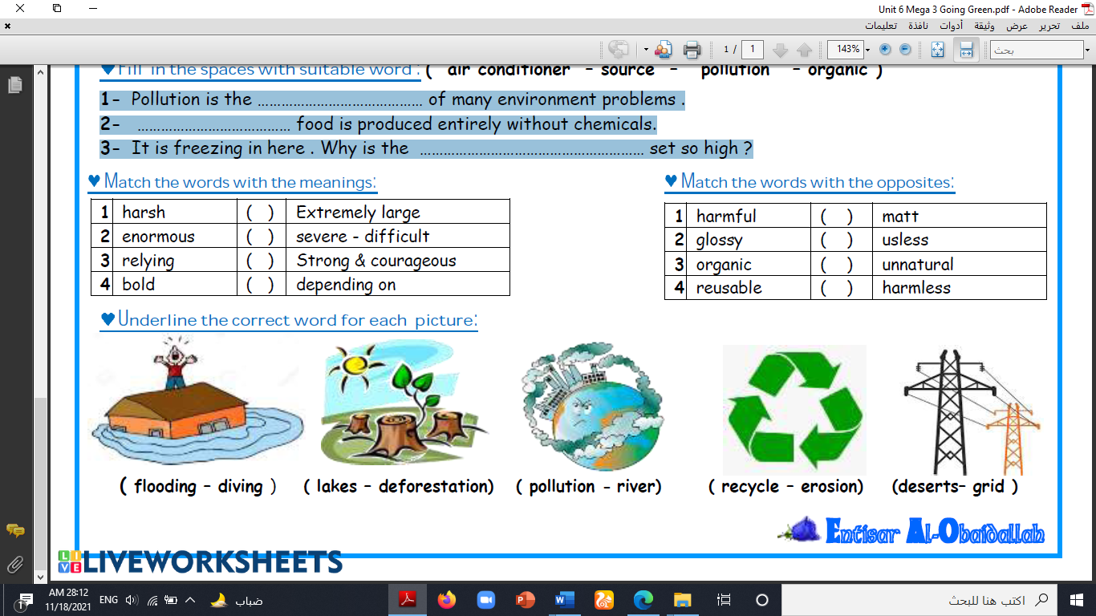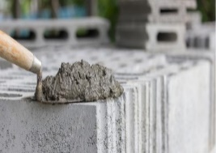

**( ) ( ) ( ) ( ) ( ) ( )**

**B- Match to form new words or expressions:**

**1. status ------ a. in a difficult situation**

**2. in a bind ------ b. state or condition**

**3. a hassle ------ c. Stop for a moment!**

**4. lodge ------ d. make a mistake**

**5. Hold on ------ e. something that is inconvenient to do**

**6. mess up ------ f. provide accommodation**

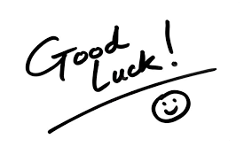**End of Questions**

**Best of Luck** [**https://t.me/abokhaledamer**](https://t.me/abokhaledamer)